**Booting and System Management Daemons**

**Booting Process Overview**

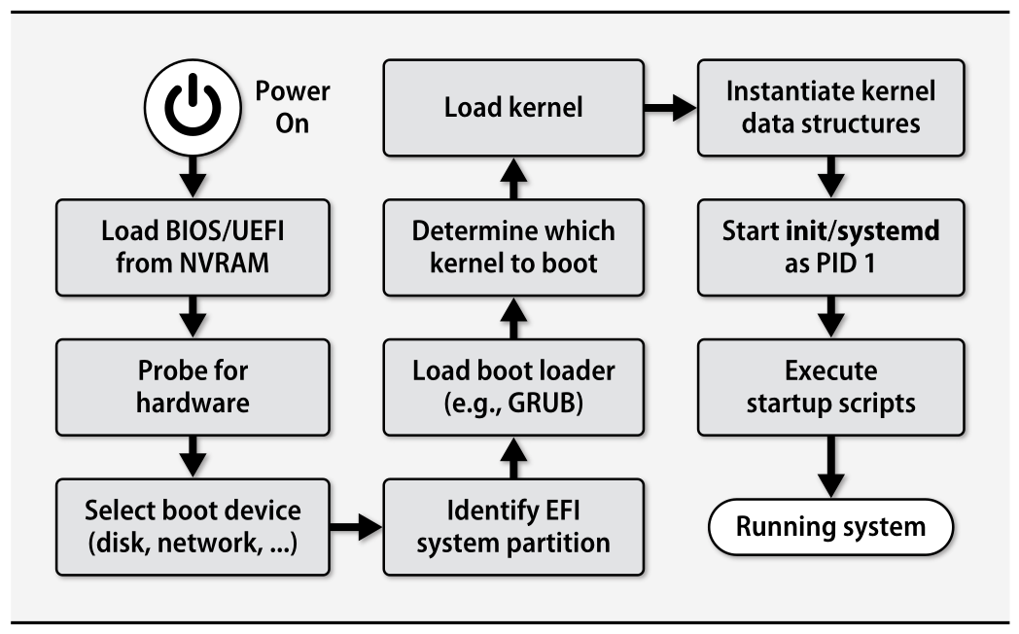

The booting process consists of a few broadly defined tasks:

1. Finding, loading, and running bootstrapping code.
2. Finding, loading, and running the OS kernel.
3. Running startup scripts and system daemons.
4. Maintaining process hygiene and managing system state transitions.

**Steps Involved in Booting**

1. The power button is hardwired with the CPU and when the power button is clicked the CPU turns on.
2. The CPU loads the BIOS/UEFI from the NVRAM
3. The BIOs/UEFI runs a check called POST (Power On Self Test) which ensures if the pieces of the hardware connected to the system works properly and if there is any error it is displayed on the screen.
4. The BIOS/UEFI then finds the device from which it has to boot the boot loader like Hard disk, Removable drive, CD, etc.
5. The BIOS/UEFI then identifies the place where the boot loader code lives, say MBR (Master Boot Record) in case of BIOS system and EFI partition in case of UEFI system.

**BIOS System**

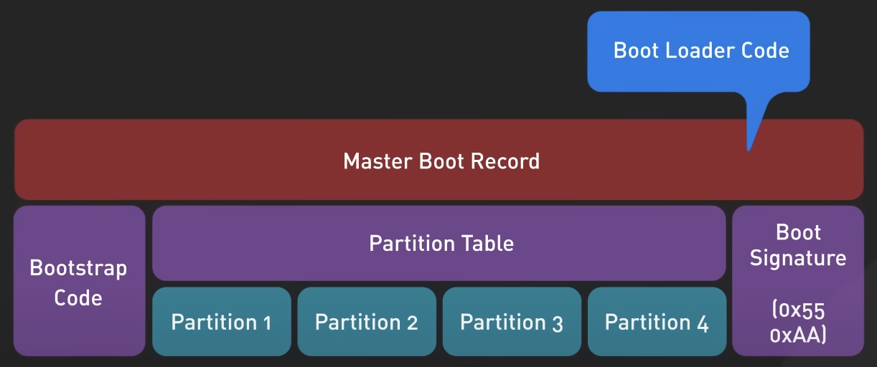

**UEFI System**

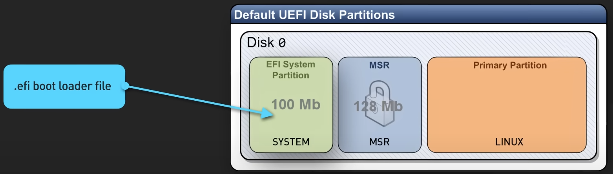

1. The boot loader determines which kernel to boot and then inserts the kernel into memory and the BIOS/UEFI hands over the control to the kernel.
2. Now the kernel takes over the computer’s resources then starts the background processes & services, it checks the hardwares and loads the device drivers and other kernel modules.
3. After this the first process Systemd starts with PID 1, it checks for any remaining hardware drivers that are left out to be loaded, executes startup scripts, mounts all filesystems and disks and GUI environment.